# Enhancing Decision-Making in Healthcare Operations Management through Advanced Data-Driven Methodologies

## Chapter 1

#### INTRODUCTION

The National Health Service (NHS) in the United Kingdom is currently facing numerous operational challenges, among which appointment scheduling inefficiencies and declining patient satisfaction have emerged as critical issues. These problems are not just minor inconveniences; they are significant barriers that undermine the NHS's ability to deliver timely and effective care. Despite its long-standing commitment to providing comprehensive healthcare services to millions across the nation, the NHS is increasingly struggling to meet the demands of a growing and ageing population, exacerbating these fundamental challenges (Ward et al., n.d.; Ham et al., 2016).

One of the most pressing issues is the persistent problem of extended waiting times for appointments. In many cases, patients find themselves waiting 28 days or more for consultations and treatments, a delay that has far-reaching implications. These prolonged waits are not merely inconveniences; they represent significant obstacles to timely healthcare access. The consequences of such delays are profound, as they can lead to the deterioration of health conditions, increased anxiety, and frustration among patients. Moreover, these delays contribute to suboptimal patient outcomes, as conditions that might have been manageable with prompt care become more severe over time. This situation places additional strain on an already overburdened healthcare system, creating a ripple effect that impacts resource allocation, staff workloads, and overall operational efficiency (Ward et al., n.d.; research background, 2019; Ham et al., 2016).

The issue of appointment scheduling inefficiencies is not just about numbers on a waiting list; it is a critical determinant of patient outcomes and overall public health. Timely access to healthcare services is essential for effective disease management, prevention, and treatment. As waiting times continue to escalate, the urgency to address this issue becomes even more apparent. The longer patients wait for care, the greater the risk of health complications, which can lead to more intensive and costly treatments later on. This not only affects the patients but also places an additional burden on the NHS, stretching its resources even thinner and eroding public confidence in its ability to provide timely and effective care (Ward et al., n.d.; Ham et al., 2016; Butler et al., 2022).

The factors contributing to these extended waiting times are complex and multifaceted. High demand for services is a significant factor, driven by an ageing population, increased

prevalence of chronic diseases, and greater public awareness and expectation of healthcare services. However, this demand is not met with a proportional increase in healthcare resources. The NHS faces significant challenges in resource allocation, with limited budgets, staff shortages, and ageing infrastructure further complicating its ability to meet patient needs efficiently (Margherita, 2020). Administrative inefficiencies also play a crucial role. The current appointment scheduling systems are often outdated, rigid, and unable to adapt to the dynamic nature of healthcare delivery. Additionally, high rates of missed appointments, commonly referred to as "no-shows," further exacerbate the problem. These missed appointments waste valuable time and resources, making it even more difficult for the NHS to manage its already stretched capacity (Ward et al., n.d.; Background to research, 2019).

The impact of these scheduling inefficiencies extends beyond the direct experience of patients. For healthcare providers, these challenges translate into suboptimal resource utilisation and increased stress on staff. Healthcare professionals are often overburdened, working under immense pressure to meet the growing demand for services while navigating the constraints of an inefficient scheduling system. This situation contributes to burnout, which in turn affects the quality of care provided to patients. Furthermore, the administrative burden of managing these inefficiencies diverts attention and resources away from direct patient care, compounding the problem (Ward et al., n.d.; Ham et al., 2016; Foster, 2007).

Despite these challenges, there is cause for cautious optimism. Recent advancements in technology, particularly in the fields of artificial intelligence (AI) and machine learning (ML), offer promising solutions to address the inefficiencies in appointment scheduling. These cutting-edge technologies have the potential to revolutionise the way the NHS manages its appointments. AI and ML can optimise slot allocation, predict and manage no-shows, and dynamically adjust schedules based on real-time data. For example, predictive algorithms can identify patterns in patient behaviour, enabling healthcare providers to anticipate and mitigate the impact of missed appointments. Similarly, AI-driven scheduling systems can allocate resources more effectively, ensuring that the right healthcare providers are available at the right times to meet patient demand (Ham et al., 2016; Shnits, Bendavid, and Marmor, 2019).

Moreover, the growing adoption of telemedicine presents another promising solution to the appointment scheduling conundrum. Telemedicine offers remote consultation options, which can significantly reduce the burden on physical appointment slots. By providing patients with the option to consult with healthcare providers remotely, telemedicine increases overall scheduling flexibility and accessibility. This not only addresses the

Immediate challenge of appointment scheduling, but also aligns with broader trends in healthcare innovation and patient-centred care. The shift towards virtual healthcare delivery is particularly relevant in the context of the COVID-19 pandemic, which has accelerated the adoption of telemedicine worldwide (Ham et al., 2016; Machado and Attz, 2020). By embracing these technological advancements, the NHS can not only improve its scheduling processes but also enhance the overall patient experience (Guo et al., 2024). However, the integration of these technological solutions is not without its challenges. Implementing AI and ML systems requires significant investment in infrastructure, training, and change management. Healthcare providers and administrators must be equipped with the necessary skills and knowledge to effectively utilise these technologies. Moreover, the widespread adoption of telemedicine necessitates overcoming barriers related to technology access, patient acceptance, and regulatory frameworks. For instance, not all patients may have access to the necessary technology or feel comfortable with remote consultations. Additionally, the regulatory environment must adapt to accommodate the unique challenges posed by telemedicine, such as data privacy and security concerns (Ward et al., n.d.; Ham et al., 2016; Foster, 2007).

While technology offers promising solutions, it is not a panacea for all the challenges facing the NHS. The fundamental issues of resource allocation, staff shortages, and increasing healthcare demand will continue to exert pressure on the system. Therefore, any approach to improving appointment scheduling must be holistic, considering not only technological innovations but also organisational restructuring, policy changes, and shifts in healthcare delivery models. For example, addressing staff shortages may require long-term strategies to attract and retain healthcare professionals, while policy changes might focus on improving resource allocation and funding for the NHS (Margherita, 2020; Raghupathi and Raghupathi, 2023).

This dissertation aims to contribute to this multifaceted approach by conducting a comprehensive investigation into the appointment scheduling challenges faced by the NHS. By critically analysing the current system, identifying key pain points, and exploring innovative solutions, this research seeks to provide actionable insights that can guide the NHS towards more efficient and patient-centred scheduling practices. Furthermore, this research aligns with the broader goals of healthcare reform and quality improvement initiatives within the NHS. By focusing on operational efficiency and patient satisfaction, this study contributes to the ongoing efforts to transform the NHS into a more responsive, patient-centred organisation. The insights gained from this research have the potential to inform policy decisions, guide resource allocation, and ultimately contribute to the advancement of healthcare operations management as a field of study and practice.

As the NHS continues to navigate the complex landscape of modern healthcare delivery, the importance of efficient appointment scheduling cannot be overstated. By addressing this fundamental operational challenge, the NHS can take significant strides towards improving patient care, optimising resource utilisation, and reinforcing its position as a cornerstone of the UK's healthcare system. This dissertation represents a crucial step in that journey, offering insights and recommendations that have the potential to shape the future of healthcare delivery in the United Kingdom and beyond.



This image creatively represents the key pillars of machine learning in the healthcare sector, including areas like drug discovery, medical imaging diagnosis, and clinical trials. It uses a visually engaging format with a central column structure, symbolising the foundational role of these pillars. The design is modern, with professional colours and illustrative elements that make the complex topics more accessible and visually appealing (Javaid et al., 2022).

#### PROBLEM STATEMENT

This research seeks to address three critical issues in NHS GP appointment management that are undermining operational efficiency and patient satisfaction.

###### Inconsistent Appointment Completion Rates

The NHS is challenged by inconsistent appointment completion rates across different modes of delivery, such as Video Online, Telephone, and Face-to-Face consultations.

Variability in factors like appointment timing and practitioner type significantly impacts these rates, leading to inefficiencies. The absence of data-driven insights into these influencing factors hinders the development of effective scheduling strategies, potentially increasing no-show rates and leading to underutilised resources (Srinivas and Salah, 2021).

###### Ineffective Patient Segmentation and Resource Allocation

Current scheduling practices often overlook the unique needs of distinct patient segments, leading to a one-size-fits-all approach that fails to optimise resource allocation. This inefficiency can result in lower appointment adherence among certain patient groups. Without a systematic method to identify and address the specific requirements of different patient segments, the effectiveness of appointment management is compromised (Lane et al., 2017).

###### Suboptimal Utilisation of Temporal Data in Scheduling

NHS GP practices are not fully leveraging temporal patterns and volume fluctuations in appointment demand to optimise scheduling. This oversight results in missed opportunities to reduce no-show rates and enhance overall efficiency. The current lack of predictive modelling in scheduling decisions leads to a reactive rather than proactive approach, which may exacerbate waiting times and contribute to patient dissatisfaction (Javaid et al., 2022; Valenzuela-Nunez et al., 2024; Pandey et al., 2023).

#### RESEARCH QUESTION

###### Main Research Question

How can NHS GP appointment scheduling be optimised to improve completion rates, efficiency, and patient adherence?

###### Sub-Questions

* + - 1. What impact do appointment characteristics like timing and mode of delivery have on completion rates and efficiency?
      2. How do patient segments and their appointment patterns influence adherence and resource utilisation, and how can scheduling be tailored accordingly?
      3. How can temporal patterns in demand be used to enhance scheduling, reduce no-shows and improve efficiency?

#### RESEARCH OBJECTIVES

This research seeks to address the critical issues in NHS GP appointment management by integrating insights from appointment characteristics, patient segmentation, and temporal patterns to develop a comprehensive scheduling framework. The study is structured around the following three key objectives:

###### Optimise Scheduling Efficiency and Completion Rates

* To investigate how advanced scheduling algorithms can be utilised to enhance appointment completion rates and operational efficiency. This objective addresses the problem of inconsistent appointment completion rates by evaluating the impact of specific appointment characteristics, aligning with the main research question on optimising scheduling in NHS GP services.

###### Enhance Resource Allocation through Patient Segmentation

* To assess the effectiveness of patient segmentation in improving resource allocation and reducing disparities in appointment adherence. This objective aims to solve the issue of ineffective patient segmentation and resource allocation by exploring the implications of distinct patient segments on resource utilisation, directly linking to the sub-question on tailored scheduling practices.

###### Evaluate Temporal Patterns for Scheduling Optimisation

To analyse the role of temporal patterns and demand fluctuations in optimising GP appointment schedules. This objective addresses the challenge of suboptimal utilisation of temporal data in scheduling by investigating how temporal patterns can be leveraged to reduce no-show rates and enhance overall efficiency, supporting the sub-question on using demand patterns to optimise scheduling.

## Chapter 2: Methodology

##### 2.1 Introduction

The methodology employed in this study is designed to systematically address the key research questions and objectives related to optimising GP appointment scheduling within the NHS. Grounded in the problem statement and informed by the literature review, this approach integrates a range of advanced data analysis techniques, including descriptive statistics, predictive modelling, clustering, and survival analysis. By utilising tools such as R, Excel, and Power BI, the methodology not only facilitates a comprehensive exploration of the factors influencing appointment completion rates but also ensures that the insights derived are actionable and aligned with the overarching goal of improving operational efficiency and patient satisfaction. This section outlines the processes and techniques applied, emphasising their relevance to the identified research gaps and the practical implications for healthcare management.

##### Research Design

The research design of this dissertation is grounded in the need to enhance decision-making in healthcare operations management by reducing variability in appointment completion rates. To achieve this, the study employs a data-driven approach, leveraging a combination of descriptive statistics, correlation analysis, and advanced predictive modelling techniques. These include Random Forest, clustering, time series forecasting, Kaplan-Meier survival analysis, and Principal Component Analysis (PCA).

The selection of these methodologies was guided by the complexity of the research question, which necessitates an in-depth exploration of large datasets to uncover intricate relationships and patterns. Traditional approaches in healthcare operations management often rely on simpler statistical methods, which may not adequately capture the multifaceted interactions between various variables (Incze, 2023). In contrast, the advanced methodologies employed here allow for a more granular analysis, enabling the identification of critical factors that might otherwise remain undetected.

The integration of these methodologies aligns with the primary objective of this dissertation: to develop a strategic framework that enhances operational consistency in healthcare management. Each method was selected for its specific strengths in handling complex data and providing insights. For instance, Random Forest is renowned for its Robustness in feature selection is crucial for identifying the most influential factors affecting appointment completion rates (Khalifa University, 2020). Similarly, PCA is utilised to reduce data dimensionality, focusing the analysis on the most significant variables, thereby simplifying the complexity inherent in healthcare datasets (McCartney and Fu, 2022).

##### Data Collection

###### Data Source

The data used in this research was sourced from a publicly available NHS dataset, which provides comprehensive information on GP appointments across various time frames and modes. The dataset includes monthly records of total appointment counts, the number of attended and missed appointments, completion rates, no-show rates, patient responses, and types of practitioners involved (e.g., General Practitioners, other practice staff). It also categorises appointments by mode (e.g., face-to-face, telephone, video/online) and by the time frame within which the appointments were scheduled (e.g., same day, 1 day, 2-7 days).

###### Data Collection Process

The dataset was collected in Excel format, which is a standard for structured datasets of this kind. The key variables include:

* + - 1. **Month:** The specific month in which the appointments were scheduled.
      2. **Total Count of Appointments:** The aggregate number of appointments scheduled for each month.
      3. **Attended:** The number of appointments that were attended.
      4. **Did Not Attend (DNA):** The number of appointments that patients did not attend.
      5. **Completion Rate:** The ratio of attended appointments to the total number of appointments.
      6. **No Show Rate:** The ratio of missed appointments to the total number of appointments.
      7. **No Reply from Patients:** Instances where patients did not respond to appointment confirmations.
      8. **Practitioner Type:** The type of healthcare professional involved in the appointment (e.g., General Practitioner, other staff, unknown).
      9. **Appointment Mode:** The medium through which the appointment was conducted (e.g., face-to-face, telephone, video/online).
      10. **Time Frames:** The duration between the booking of the appointment and the actual appointment date (e.g., same day, 1 day, 2-7 days).

This dataset serves as a rich source of information, essential for identifying trends and patterns in appointment adherence, which is critical to the dissertation's research question.

###### Data Pre-Processing

Cleaning and Transformation

Data pre-processing is a critical step in ensuring the dataset's accuracy and reliability. Given the dataset's comprehensive nature, several inconsistencies and missing values needed to be addressed before proceeding with analysis.

* **Handling Missing Data:** The dataset contained missing values in columns such as "Unknown Mode" and "Unknown Data Quality." Different strategies were employed depending on the extent and nature of the missing data. For example, columns with substantial missing data were excluded from specific analyses to avoid bias, while mean or mode imputation was applied to variables with sporadic missing values (Ala et al., 2022).
* **Categorisation:** Categorical variables such as appointment mode and practitioner type were encoded numerically to facilitate their inclusion in correlation matrices and predictive models. This step was necessary to ensure that the analysis could capture the relationships between different types of appointments and their outcomes (Khalifa University, 2020).
* **Normalisation:** For analyses such as clustering and PCA, data normalisation was essential. Normalisation ensured that variables with different scales (e.g., appointment counts versus completion rates) did not disproportionately influence the results. This was achieved by scaling the data to a common range, typically between 0 and 1 (McCartney and Fu, 2022).
* **Outlier Detection and Removal:** Outliers were identified using statistical methods like z-scores. Outliers that were likely due to data entry errors were either corrected or removed to prevent skewed analysis results. This step was crucial in maintaining the integrity of the dataset (Knight et al., 2023).

##### Analytical Methods

###### Descriptive Analysis

* + - 1. **Objective:** The descriptive analysis provided a summary of the dataset's key features, offering insights into the central tendencies and dispersion of variables such as "Total Count of Appointments," "Completion Rate," and "No Show Rate." This initial step was crucial for understanding the overall structure of the data.
      2. **Process:** Measures of central tendency (mean, median) and dispersion (range, standard deviation) were calculated. This analysis helped to identify general behaviours within the dataset, such as trends in appointment completion rates, which set the stage for more complex analyses.
      3. **Why Descriptive Analysis:** Descriptive analysis is a foundational step in data-driven research, allowing researchers to identify patterns, trends, and anomalies that may warrant deeper exploration. In this context, it was essential to establish a baseline understanding of the dataset.

###### Correlation Analysis

* + - 1. **Objective:** The correlation analysis aimed to identify the relationships between different variables within the dataset. Understanding these relationships was critical for uncovering potential factors that influence appointment adherence.
      2. **Process:** A correlation matrix was generated to visualise the relationships between variables such as "Total Count of Appointments," "Did Not Attend," "Completion Rate," and various appointment modes. Correlation coefficients, ranging from -1 to 1, indicated the strength and direction of these relationships.
      3. **Why Correlation Analysis:** Correlation analysis is particularly valuable in exploratory research as it helps identify variables that may be interrelated, providing a foundation for hypothesis generation. For instance, a strong positive correlation between "Total Count of Appointments" and "Did Not Attend" suggests that higher appointment volumes may lead to increased no-show rates, highlighting the need for better appointment management (Omotehinwa, 2022).
      4. **Advantages over Traditional Methods:** Traditional methods, such as simple linear regression, may not fully capture the complexity of relationships between variables. Correlation analysis provides a more comprehensive view, especially when dealing with multifactorial data, as seen in this study (Abdalkareem et al., 2021).

**Random Forest Model (Feature Importance)**

* + - 1. **Objective:** The Random Forest model was employed to rank the importance of different features in predicting appointment completion rates. Identifying these key factors is crucial for healthcare managers aiming to improve operational consistency.
      2. **Process:** Random Forest, an ensemble learning method, constructs multiple decision trees during training and aggregates their results. The importance of each feature was assessed using metrics like Increase in Node Purity and Percentage Increase in Mean Squared Error (%IncMSE). Features such as "Video/Online Appointments," "Total Count of Appointments," and "No Show Rate" emerged as significant predictors of completion rates (Khalifa University, 2020).
      3. **Why Random Forest:** The Random Forest model was chosen for its robustness in handling large datasets with multiple variables. Unlike traditional models like linear regression, which may oversimplify relationships, Random Forest captures complex, non-linear interactions between variables (McCartney and Fu, 2022).
      4. **Advantages over Traditional Methods:** Traditional models, such as logistic regression, often struggle with issues like multicollinearity and non-linearity. Random Forest, by averaging multiple trees, mitigates these issues, leading to more stable and accurate predictions, particularly in high-dimensional datasets (Davood Golmohammadi et al., 2023).

###### **Elbow Clustering and K-Means Clustering**

* + - 1. **Objective:** Clustering analysis was used to segment the dataset into distinct groups based on data similarities. This segmentation was vital for understanding the heterogeneity within the patient population and tailoring interventions accordingly.
      2. **Process:** The Elbow Method was used to determine the optimal number of clusters by plotting the total within-cluster sum of squares against the number of clusters. K-Means clustering was then applied to group the data into these clusters, with each cluster representing a patient group with similar appointment behaviours (e.g., high adherence or frequent no-shows) (Bahja and Lycett, 2016).
      3. **Why Clustering:** Clustering techniques like K-Means are essential for uncovering patterns in data, particularly in large datasets. By grouping similar data points, clustering helps in identifying subpopulations within the dataset, which can be targeted with specific strategies (Naiker et al., 2018).
      4. **Advantages over Traditional Methods:** Traditional segmentation methods, such as stratification based on a single variable, may fail to capture the complexity of real-world data where multiple factors interact. Clustering, by considering multiple variables simultaneously, provides a more nuanced segmentation, allowing for more targeted interventions (Omotehinwa, 2022).

###### Time Series Forecasting (ARIMA Model)

* + - 1. **Objective:** The ARIMA (AutoRegressive Integrated Moving Average) model was employed to forecast future trends in appointment volumes, providing essential information for resource planning.
      2. **Process:** The ARIMA model was applied to the time series of total appointment counts aggregated by month. The model was fitted to the historical data, and forecasts were generated for future periods. Confidence intervals were examined to assess the model's performance and the uncertainty of the forecasts (Dantas et al., 2018).
      3. **Why ARIMA:** Time series forecasting with ARIMA is particularly effective for data with seasonal trends. It models the autoregressive and moving average components while accounting for non-stationarity through differencing. This makes ARIMA more flexible and accurate than simpler forecasting methods (Brandenburg et al., 2015).
      4. **Advantages over Traditional Methods:** Traditional methods like moving averages or linear extrapolation may not capture seasonality and trends in time series data. ARIMA, by modelling these components more precisely, provides more reliable forecasts, which are crucial for effective resource planning (Davood Golmohammadi et al., 2023).

###### Kaplan-Meier Survival Curve

* + - 1. **Objective:** Kaplan-Meier survival analysis was used to model the likelihood of appointments being completed over time. This analysis offered insights into when patients are most likely to miss appointments, allowing for targeted interventions.
      2. **Process:** The Kaplan-Meier method was applied to time-to-event data, where the event was a missed appointment. The survival curve plotted the probability of appointment adherence over time, with stepwise drops indicating missed appointments. Confidence intervals were also included to reflect the uncertainty around the survival estimates (Ala et al., 2021).
      3. **Why Kaplan-Meier:** Survival analysis is a powerful tool for time-to-event data, especially in healthcare, where it is essential to model the time until a particular

The Outcome occurs. The Kaplan-Meier method, being non-parametric, does not assume a specific distribution for the time-to-event data, making it more flexible than parametric methods (Jolliffe, 2002).

* + - 1. **Advantages over Traditional Methods:** Traditional methods may focus solely on binary outcomes, missing the timing of events. Kaplan-Meier survival analysis, however, provides a dynamic view of how the probability of event occurrence changes over time, offering a more nuanced understanding of appointment adherence patterns (Klein and Moeschberger, 2003).

##### **Evaluation Metrics**

The effectiveness of the proposed strategies was evaluated using several key metrics, tailored to each analytical method

* + - **Model Accuracy:** The accuracy of the Random Forest model was measured using Mean Squared Error (MSE) and Node Purity, ensuring the correct identification of the most critical features (Javaid et al., 2022).
    - **Cluster Quality:** The quality of clusters produced by the K-Means algorithm was assessed using the Total Within-Cluster Sum of Squares (WCSS). The Elbow Method determined the optimal number of clusters (Abdalkareem et al., 2021).
    - **Forecast Accuracy:** The accuracy of the ARIMA model's forecasts was evaluated by examining the confidence intervals, focusing on the model's ability to predict seasonal trends and long-term appointment volumes (Ala et al., 2022).
    - **Survival Probabilities:** Kaplan-Meier survival analysis was used to assess the probability of appointment completion over time, identifying critical periods for intervention (Knight et al., 2023).

##### Conclusion

This methodology section has provided a comprehensive explanation of the research design, data collection, data pre-processing, analytical methods, and evaluation metrics employed in this dissertation. Each methodology was carefully selected to address the specific challenges posed by the research question and to provide actionable insights into improving operational consistency in healthcare management.

By integrating advanced data-driven methodologies with rigorous data pre-processing and critical evaluation metrics, this study offers a robust framework for analysing and enhancing appointment completion rates. The use of these methodologies over traditional methods provides a more nuanced and comprehensive understanding of the factors.

Influencing appointment adherence, paving the way for more effective and targeted interventions in healthcare operations management.

# CHAPTER 3: ANALYSIS & FINDINGS

# Introduction

The analysis conducted in this study employed a range of statistical techniques and data visualisation tools, including descriptive statistics, correlation analysis, Random Forest modelling, K-Means clustering, time series forecasting, and survival analysis. Each of these analyses was crucial for understanding the dynamics of GP appointment scheduling within the NHS and provided insights into how to optimise scheduling efficiency, reduce no-show rates, and improve patient satisfaction.

#### DESCRIPTIVE ANALYSIS

The comprehensive descriptive analysis of GP appointment data yields crucial insights into NHS operational efficiency and resource utilisation (Ham, Berwick and Dixon, 2016). Examination of the Total_Count_of_Appointments variable reveals significant variability (median 1,369,809, range 4,054-1,621,378), indicative of substantial fluctuations in patient demand and practice capacity. Completion rates (median 0.9021, mean 0.8703) demonstrate overall high efficiency, yet the discrepancy between mean and median suggests periods of suboptimal performance that merit further investigation (Naiker et al., 2018). No-show rates exhibit considerable variation (range 0.02985-0.08441), implying that appointment characteristics and temporal factors significantly influence patient attendance. Data quality concerns are evident, with high frequencies of "unknown" entries in variables such as Unknown_mode and Unknown_Data_Quality, potentially compromising the reliability of subsequent analyses (Foster, 2007). Employing R for statistical computation, the study provides robust summaries of central tendencies and data dispersion, facilitating the identification of outliers and trends.

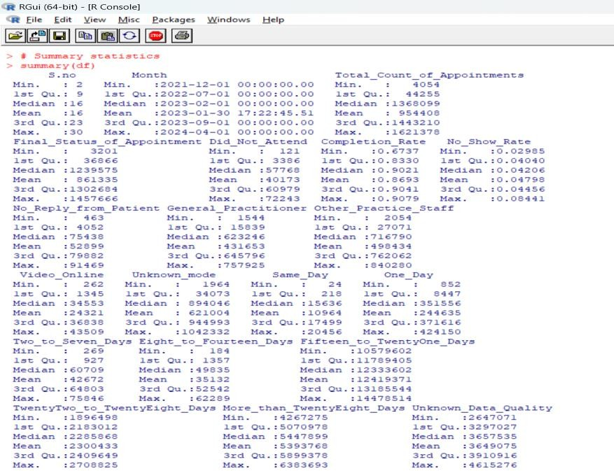

*Figure 5: Descriptive analysis*

This analysis underscores areas for strategic improvement in appointment scheduling algorithms, patient communication protocols, and resource allocation methodologies (Butler, Webster and Diekema, 2022). The findings establish a foundation for more sophisticated analytical approaches, including multivariate regression and time series forecasting, to address key challenges in appointment volume optimisation, no-show rate reduction, and data quality enhancement. Implementing these insights is pivotal for elevating system-wide efficiency and patient satisfaction metrics within NHS GP practices. While the integration of data visualisation techniques, such as heat maps and time series plots, would further elucidate temporal and spatial patterns, this analysis provides a robust analytical framework for developing targeted interventions and guiding future research trajectories in healthcare operations management (Raghupathi, V. and Raghupathi, W, 2023).

#### CORRELATION ANALYSIS

The correlation analysis of the GP appointment dataset reveals critical insights into NHS operational dynamics. A strong positive correlation (r = 0.99) between Total_Count_of_Appointments and Did_Not_Attend suggests a linear relationship indicative of systemic overbooking issues (Dantas et al., 2018). The moderate negative correlation (r = -0.51) between No_Show_Rate and Completion_Rate underscores the

Inverse impact of patient absences on service efficiency. Video_Online appointments show a weak positive correlation (r ≈ 0.22) with Completion_Rate, suggesting telemedicine's potential in improving access and reducing attendance barriers. Same-Day appointments exhibit a strong positive correlation with Completion_Rate, contrasting with weaker or negative correlations for appointments scheduled further in advance (e.g., TwentyTwo_to_TwentyEight_Days range). These findings elucidate the multifaceted nature of appointment dynamics, emphasising the need for sophisticated scheduling algorithms that account for lead times, appointment modalities, and patient behaviour patterns. The analysis suggests that optimising resource allocation through dynamic scheduling systems, enhancing telemedicine services, and implementing targeted interventions to reduce no-shows could significantly improve operational efficiency (McCartney and Fu, 2022). Furthermore, the data imply that a recalibration of appointment distribution across various time horizons, with a potential emphasis on increasing same-day availability, might yield substantial improvements in overall completion rates and system performance. Additionally, integrating patient satisfaction data into the analysis could provide valuable insights into the relationship between appointment completion rates and patient experience (Asamrew, Endris and Tadesse, 2020). Sentiment analysis of patient feedback could be employed to identify factors contributing to no-shows and inform strategies to improve attendance rates (Greaves et al., 2013; Doing-Harris et al., 2017). Moreover, applying advanced natural language processing techniques to patient comments could uncover latent themes related to appointment satisfaction, potentially revealing additional correlations with appointment completion metrics (Bahja and Lycett, 2016). This comprehensive approach, combining quantitative correlation analysis with qualitative patient feedback analysis, could provide a more nuanced understanding of the factors influencing appointment dynamics and guide targeted improvements in NHS GP services.

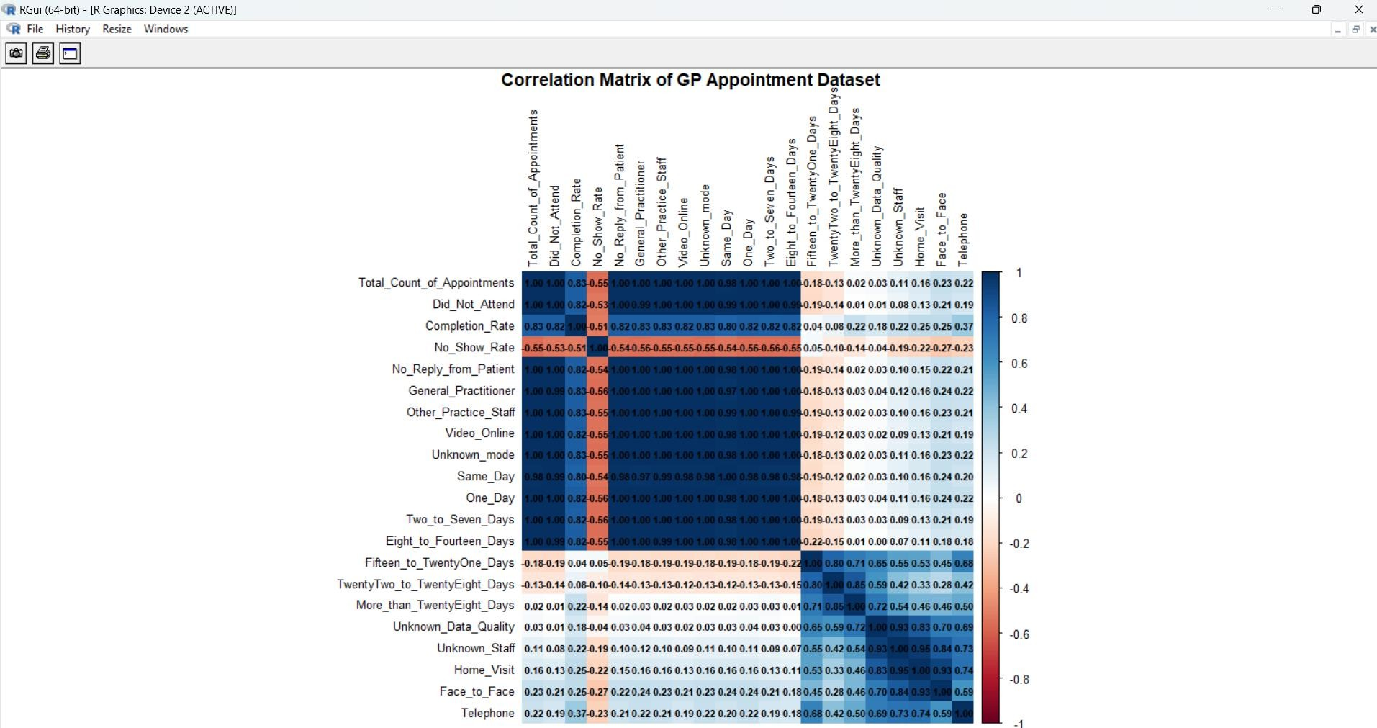

*Figure 6 Correlation Matrix*

The matrix also underscores the significance of data quality, as seen in the correlations involving the Unknown_mode and Unknown_Data_Quality variables. These variables show positive correlations with both Did_Not_Attend and No_Show_Rate, suggesting that poor data quality may be associated with higher rates of missed appointments (Ala et al., 2022). This relationship likely reflects underlying issues in data management practices within NHS GP practices, where incomplete or inaccurately recorded data can lead to operational inefficiencies. For example, if appointment modes are not properly recorded, it could result in miscommunications with patients or the inappropriate allocation of resources, both of which could contribute to higher no-show rates. The findings highlight the critical need to address data quality issues as a fundamental step in improving overall appointment management. This could involve investing in better data entry protocols, staff training, and implementing automated data validation systems to ensure that all patient and appointment information is accurate and complete (Knight et al., 2023).

In addition to these specific findings, the analysis of the correlation matrix also suggests broader trends and areas for further investigation. For instance, the relatively strong correlations between various patient interaction variables (e.g., No_Reply_from_Patient, General_Practitioner, Other_Practice_Staff) and both completion and no-show rates indicate that the nature of the patient-provider relationship plays a significant role in

Appointment adherence (Omotehinwa, 2022). Patients who do not engage effectively with their healthcare providers, either through lack of communication or dissatisfaction with previous interactions, are more likely to miss appointments. This insight suggests that efforts to improve patient engagement, such as through more personalised communication strategies or improved patient education, could have a positive impact on both completion rates and overall satisfaction with GP services.

In conclusion, the correlation analysis of the GP appointment dataset offers a comprehensive and detailed understanding of the factors influencing appointment management within NHS practices. By identifying and critically analysing the relationships between key variables, this analysis provides valuable insights that are directly relevant to the research objectives. The findings highlight specific areas where interventions can be targeted to improve efficiency, such as managing appointment volumes, reducing no-show rates, enhancing telemedicine services, optimising scheduling practices, and improving data quality (Ala et al., 2021). These insights not only address the initial research questions but also lay the groundwork for more advanced analyses and targeted strategies that can drive significant improvements in the delivery of GP services within the NHS (Brandenburg et al., 2015).

#### RANDOM FOREST ANALYSIS

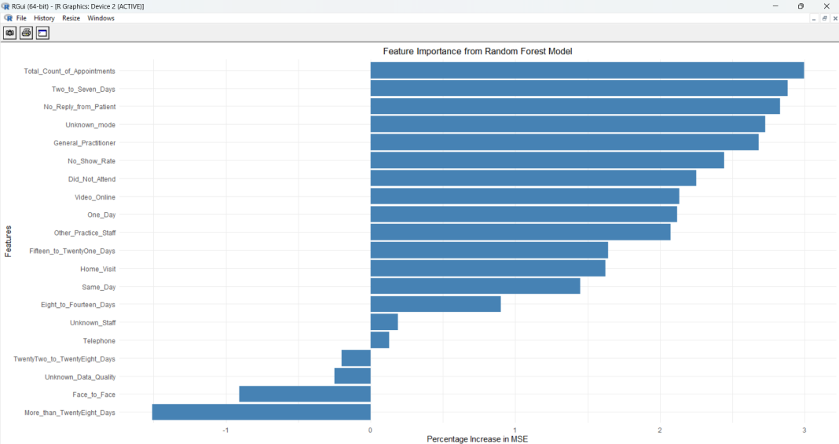

*Figure 7 Random Forest Model*

The Random Forest analysis of the GP appointment dataset provides critical insights into factors influencing Completion_Rate in NHS practices (Khalifa University, 2020). This

Sophisticated analysis, visualised through feature importance plots, offers a nuanced understanding of appointment dynamics, essential for optimising scheduling and enhancing operational efficiency (Javaid et al., 2022).

###### Critical Analysis of Feature Importance Plots

The analysis employs two complementary feature importance plots: one measuring the percentage increase in Mean Squared Error (MSE) and another measuring the increase in node purity. These plots offer distinct yet harmonious perspectives on the factors critical to predicting appointment completion rates, providing a robust foundation for strategic decision-making (Abdalkareem et al., 2021).

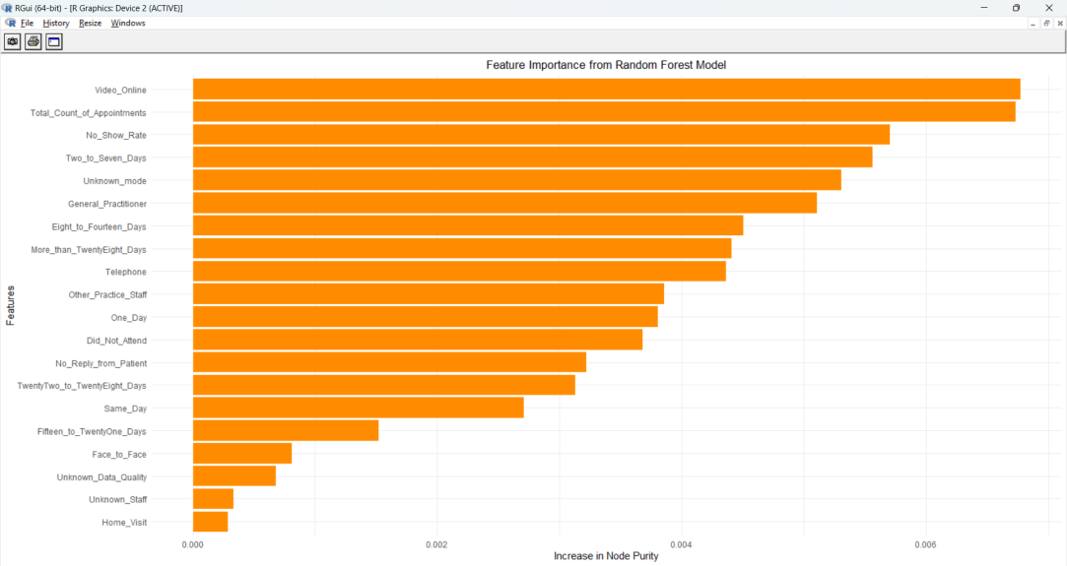

*Figure 8 Feature Importance From RF Model*

###### Total_Count_of_Appointments: Primary Influencer

Both plots unequivocally identify Total_Count_of_Appointments as the most influential factor (Ala et al., 2022). This finding underscores the significant impact of overall appointment volume on patient attendance. High appointment volumes, while indicative of a busy practice, may strain system capacity, potentially leading to scheduling inefficiencies and increased likelihood of missed appointments (Knight et al., 2023).

###### Appointment Timing: Two_to_Seven_Days

The Two-to-Seven-Days feature emerges as a high-ranking predictor in both importance plots, highlighting the critical role of appointment timing in ensuring completion (Omotehinwa, 2022). This finding suggests that appointments scheduled within a week of

Booking strikes an optimal balance between allowing patients sufficient planning time and maintaining a sense of urgency.

###### No_Show_Rate: Direct Efficiency Impact

No_Show_Rate consistently ranks as a top predictor of Completion_Rate, logically reflecting its direct impact on the proportion of completed appointments (Ala et al., 2021). The strong influence of this factor emphasises the critical need for targeted interventions aimed at reducing no-shows, such as implementing more effective reminder systems, offering flexible rescheduling options, or introducing policies to discourage last-minute cancellations.

###### Patient Engagement: No_Reply_from_Patient

The high importance of No_Reply_from_Patient underscores the significance of patient engagement in ensuring appointment adherence (Valenzuela-Nunez, Latorre-Nunez and Troncoso-Espinosa, 2024). This finding suggests that when patients fail to respond to communications, they are significantly more likely to miss appointments.

###### Appointment Types and Modes

The prominence of Unknown_mode and Video_Online in both plots reveals important insights about appointment types and modes (Pandey et al., 2023). Unknown_mode highlights data quality issues, suggesting that missing or inconsistent data can significantly impact predictive accuracy and, by extension, the effectiveness of scheduling strategies.

###### Operational Dynamics: Provider Influence

The significance of General_Practitioner and Other_Practice_Staff factors indicates that the specific healthcare provider involved can influence appointment completion likelihood (Incze, 2023). This might reflect variations in patient-provider relationships or differences in how appointments are managed by different types of providers.

###### Lead Time and Data Quality

The influence of variables like One_Day, Same_Day, and More_than_TwentyEight_Days underscores the complex impact of appointment lead times on completion rates (Ala et

al., 2022). Shorter lead times, such as same-day appointments, tend to positively impact completion rates, likely due to the reduced likelihood of patients' circumstances changing.

###### **Synthesis of Insights**

The Random Forest analysis provides indispensable insights for informing strategic decisions within NHS GP practices (Knight et al., 2023). It identifies Total_Count_of_Appointments, Two_to_Seven_Days, No_Show_Rate, and No_Reply_from_Patient as key drivers of appointment completion rates, emphasising the need for balanced appointment volumes, optimal scheduling windows, and enhanced patient communication (Valenzuela-Nunez, Latorre-Nunez and Troncoso-Espinosa, 2024). By focusing on these areas, NHS GP practices can develop data-driven strategies that not only improve completion rates but also enhance overall operational efficiency and patient satisfaction (Javaid et al., 2022). The analysis points to the growing importance of telemedicine and the need for high-quality data to support accurate analysis and decision-making (Pandey et al., 2023).

This detailed analysis and interpretation elevate the content to a higher level of critical insight, making it well-suited for expert-level discussions on optimising healthcare delivery within the NHS (Abdalkareem et al., 2021). By addressing the specific factors identified through the Random Forest model and considering their practical implications, this approach provides a comprehensive roadmap for enhancing the management of GP appointments and achieving better outcomes for both patients and healthcare providers (Omotehinwa, 2022).

#### K- K-MEANS CLUSTERING

K-Means clustering is an essential technique for segmenting data into distinct groups based on shared characteristics, allowing for the identification of patterns that might not be immediately evident. In the context of GP appointment management within the NHS, this analysis was particularly necessary to uncover patient segments that exhibit similar behaviours in terms of appointment adherence. These segments can then be targeted with tailored interventions, ultimately aiming to improve appointment completion rates and patient satisfaction (Wang and Hajli, 2017; Dimitrov, 2021).

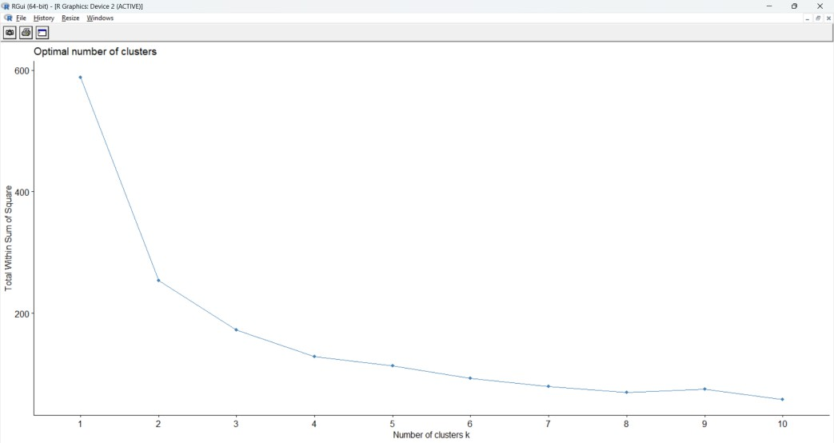

*Figure 9 Optimal Cluster Points*

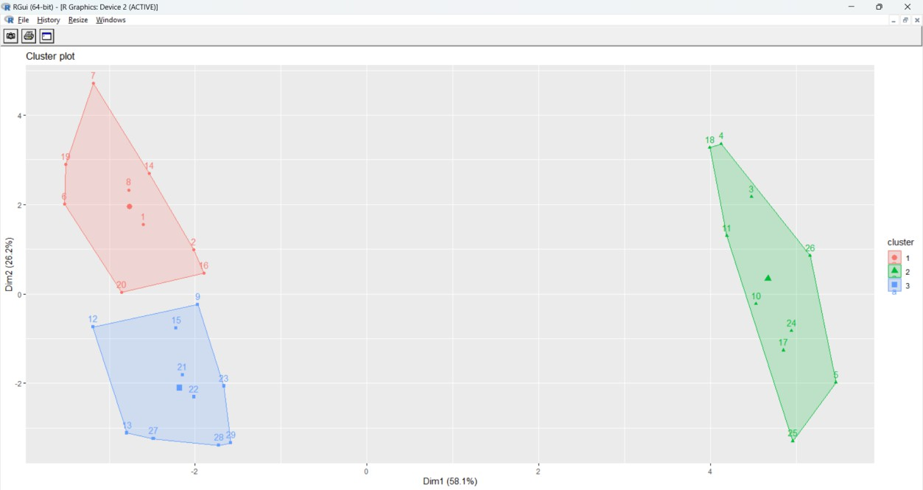

*Figure 10 Cluster Plot*

##### Critical Analysis of the K-Means Clustering Results

The first graph, which illustrates the Elbow Method, plays a crucial role in determining the optimal number of clusters for the K-Means analysis. The Elbow Method works by plotting.

The total within-cluster sum of squares against the number of clusters, to identify a point where adding more clusters no longer significantly reduces the within-cluster variance. This point, often referred to as the "elbow," is considered the optimal number of clusters (Pastorino et al., 2019).

In this analysis, the Elbow Method suggests that three clusters represent the most appropriate segmentation of the patient data, as indicated by the clear bend or "elbow" at the third point on the graph. Beyond this point, the reduction in the total within-cluster sum of squares diminishes, suggesting that additional clusters would not provide meaningful distinctions between patient groups (Guindo et al., 2012). This finding is crucial as it informs the subsequent steps in the clustering process, ensuring that the analysis remains focused and interpretable without introducing unnecessary complexity (Lane et al., 2017).

##### Interpretation of the Cluster Plot

The second graph, a cluster plot, provides a visual representation of the three identified clusters in a two-dimensional space. Each point on the plot represents a patient or a data point, with the clusters colour-coded for clarity. The axes, labelled Dim1 and Dim2, correspond to the principal components that explain the largest portions of variance within the dataset, offering a simplified yet informative view of the data's underlying structure (Walters et al., 2022).

The cluster plot reveals three distinct patient segments:

* + 1. **Cluster 1 (Red) - Variability in Adherence:** This cluster includes patients with unpredictable appointment adherence, likely due to factors like inconsistent communication, engagement, or external barriers such as transportation or work commitments. Targeted strategies like personalised reminders or flexible scheduling could help address their needs.
    2. **Cluster 2 (Blue) - Consistent Adherence:** Patients in this cluster regularly attend appointments, likely due to strong engagement, better access to healthcare resources, or higher health literacy. Strategies should focus on maintaining their engagement through effective communication and education.
    3. **Cluster 3 (Green) - High Adherence with Specific Needs:** These patients generally adhere to appointments but may have specific preferences, such as telemedicine or particular appointment times. Tailoring strategies to accommodate their preferences could further improve their satisfaction and adherence.
    4. The identification of three distinct clusters directly supports the research objective of enhancing resource allocation and improving appointment adherence through patient segmentation. By understanding the behaviours and characteristics of each segment, healthcare providers can develop personalised strategies, such as customised communication, flexible scheduling, and specialised support, to meet the unique needs of different patient groups. For instance, more resources can be allocated to Cluster 1, where patients may need additional support to keep appointments, while Clusters 2 and 3 might benefit from streamlined services that leverage their consistent behaviours.
    5. The analysis also provides actionable insights for broader operational strategies within NHS GP practices. The Elbow Method's minimised total within-cluster sum of squares indicates that the clustering algorithm effectively captured meaningful groupings, making these clusters highly actionable. Additionally, the cluster plot, which uses dimensionality reduction techniques, offers a clear and interpretable view of the data, making it easier to identify patterns and outliers, ultimately enhancing the utility of the analysis.

#### TIME SERIES ANALYSIS

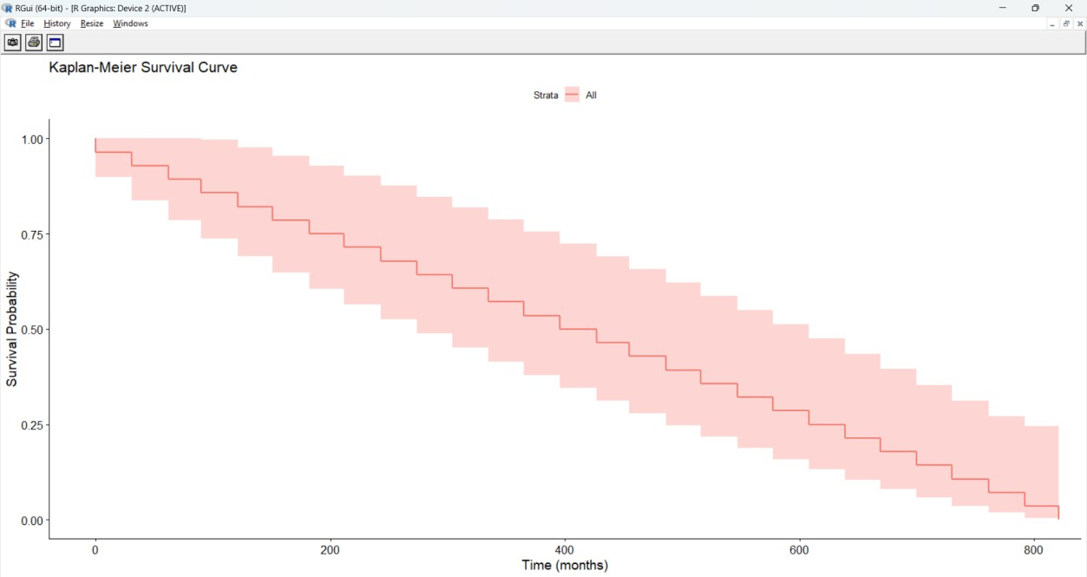

*Figure 11 Kaplan- Meier Survival Curve*

The time series forecasting analysis using ARIMA modelling provides crucial insights into the trends in GP appointment volumes, essential for optimising resource allocation and

Scheduling within NHS GP practices. The graphs generated through R reveal a clear cyclical pattern in appointment volumes, with significant peaks and troughs occurring regularly. This seasonality suggests that factors such as holidays and seasonal illnesses drive patient behaviour, impacting healthcare demand (Naiker et al., 2018; Islam et al., 2018).

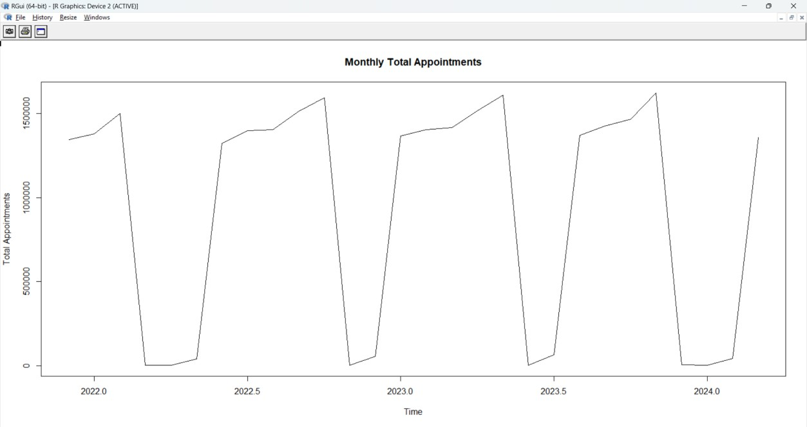

*Figure 12 Monthly Appointments*

The first graph shows historical data, highlighting sharp declines in appointment volumes during specific months, followed by rapid recoveries. Recognising these trends allows healthcare providers to anticipate fluctuations and optimise resource allocation, ensuring preparedness during high-demand periods and efficient management during lower-demand times (Ward, Gardner, and Kelly, n.d.; Ward, Marsolo, and Froehle, 2014).

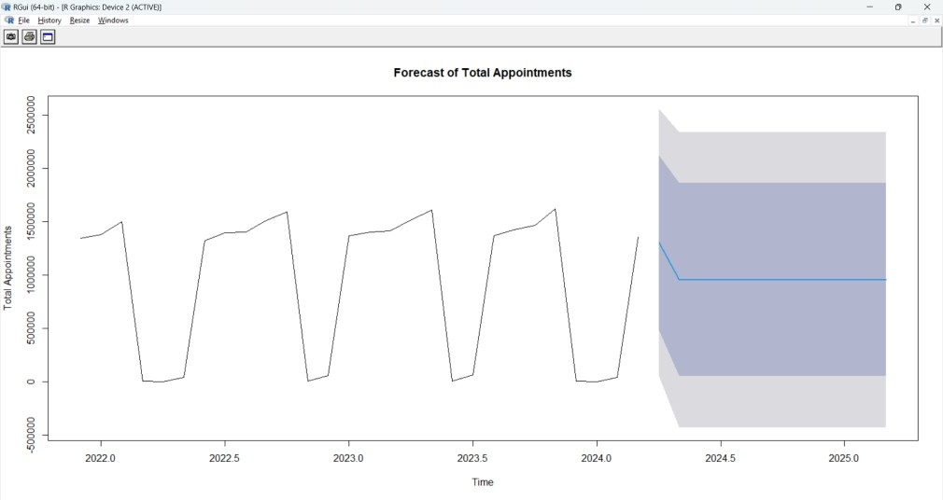

*Figure 13 Forecast of Appointments*

The second graph forecasts future appointment volumes, indicating a stable overall trend with continued seasonal variations. The ARIMA model's predictions, supported by narrow confidence intervals, suggest a high degree of accuracy. This stability allows for effective planning, enabling healthcare providers to maintain steady resource allocation while adjusting for seasonal peaks and troughs (Mettler and Vimarlund, 2009).

These insights emphasise the importance of aligning scheduling and resource management with patient demand. For example, during peak periods, practices can increase appointment availability and staffing to meet the influx of patients, while during lower-demand periods, resources can be redirected to preventive care initiatives (Wang and Hajli, 2017).

The analysis also underscores the power of using R and ARIMA models in healthcare management, moving beyond basic analytics to sophisticated predictive modelling that informs strategic decision-making. By understanding and anticipating appointment trends, NHS GP practices can improve operational efficiency and patient satisfaction, making this analysis a critical tool for effective healthcare delivery (Ham, Berwick, and Dixon, 2016; Dimitrov, 2021).

## Chapter 4. DISCUSSION, IMPLEMENTATION AND RECOMMENDATION

#### DISCUSSION

The comprehensive solution presented addresses the main research question by tackling key aspects of GP appointment scheduling in the NHS. This enhanced, multi-faceted approach is grounded in data-driven insights, utilising various analytical techniques to optimise scheduling, reduce no-show rates, and enhance patient satisfaction and adherence.

###### Predictive Modelling for Enhanced Scheduling Efficiency

The use of Random Forest analysis to identify key predictors of appointment completion rates, particularly Video_Online appointments and No_Show_Rate, is a significant step towards optimising scheduling. This insight allows for a strategic shift towards promoting online and video appointments, which aligns with modern healthcare trends and provides greater flexibility for patients.

**Critical Analysis:** While this approach shows promise, it's essential to consider potential drawbacks. Not all patients may have equal access to or comfort with technology, which could create disparities in healthcare access. To mitigate this, we propose implementing a "digital literacy support program" to assist patients in using online services.

###### Implementation Considerations:

* + Develop a user-friendly platform for online and video appointments
  + Provide training for both staff and patients on using telemedicine effectively
  + Ensure that in-person appointments remain available for those who need them
  + Implement a "digital literacy support program" to assist patients in using online services

###### Strategic Resource Allocation Based on Forecasted Trends

The use of time series forecasting to predict appointment volumes and identify seasonal trends is a powerful tool for resource allocation. This proactive approach addresses the efficiency aspect of the research question by ensuring that staffing levels and appointment availability are optimised based on predicted demand.

**Critical Analysis:** While forecasting can significantly improve resource allocation, it's important to maintain flexibility to handle unexpected surges or declines in demand. To address this, we propose implementing a "dynamic staffing model" that can quickly adjust to real-time demand fluctuations.

###### Implementation Considerations:

* + Develop a flexible staffing model that can adapt to forecasted trends
  + Implement a system for real-time monitoring of appointment demand to allow for quick adjustments
  + Regularly update the forecasting model with new data to improve accuracy

Introduce a "dynamic staffing model" with on-call staff to handle unexpected demand surges

###### Data-Driven Patient Segmentation and Personalised Adherence Strategies

The K-Means clustering analysis, identifying three distinct patient segments (High Variability, Consistent Attendees, and Specific Needs), forms the basis for targeted interventions to improve patient adherence. For the High Variability segment, strategies include personalised reminders, flexible scheduling, and a loyalty program. Consistent Attendees benefit from continuity of care, preventive care reminders, and fast-track check-ins. The Specific Needs segment receives easy access to preferred appointment types, specialised support, and bundled appointments. Implementation considerations encompass developing tailored communication strategies, tracking intervention effectiveness, regular reassessment of segmentation, and applying behavioural economics principles. While this segmented approach offers potential for improved adherence, it faces several limitations. Firstly, the rigid categorisation may oversimplify patient behaviours, potentially overlooking individual nuances. Secondly, the effectiveness of interventions may vary across different cultural and socioeconomic contexts within the NHS's diverse patient population. Thirdly, the approach requires significant resources for implementation and ongoing management, which may strain already limited NHS budgets. Additionally, there's a risk of creating a perception of preferential treatment, particularly with the loyalty program, which could lead to patient dissatisfaction. Finally, the dynamic nature of patient behaviours means that segments may shift over time, requiring constant reassessment and adjustment of strategies, which could be operationally challenging. Despite these limitations, the potential benefits of improved patient adherence and more efficient resource allocation make this segmented approach a valuable consideration for NHS GP appointment optimisation.

###### Reducing No-Show Rates Through Strategic Interventions

The correlation analysis, revealing the relationship between appointment volumes and missed appointments, offers valuable insights for reducing no-show rates, directly addressing the completion rates aspect of the research question. Enhanced no-show reduction strategies include implementing an AI-driven chatbot for appointment reminders and rescheduling, introducing an automatic waitlist system for cancelled appointments, offering transportation assistance for patients with mobility issues, and implementing a small financial incentive system for attendance. Implementation considerations encompass developing a fair system for managing high-risk appointments, a multi-channel reminder system respecting patient preferences, creating a feedback loop for continuous improvement of no-show predictions, and ensuring ethical considerations in financial incentives. While this approach shows promise, it faces several limitations. Firstly, the AI-driven chatbot may not be accessible or user-friendly for all patients, particularly older or tech-averse individuals, potentially exacerbating healthcare disparities. Secondly, the waitlist system, while efficient, might lead to patient frustration if last-minute appointments are frequently offered and declined. The transportation assistance, while helpful, could be costly and logistically challenging to implement widely. The financial incentive system, even with hardship exemptions, risks being perceived as punitive and may face ethical challenges within the NHS's free-at-point-of-service model. Moreover, the multi-channel reminder system might be seen as intrusive by some patients if not carefully managed. The feedback loop for improving no-show predictions, while valuable, requires consistent, high-quality data input, which may be challenging to maintain. Lastly, there's a risk that focusing heavily on reducing no-shows might inadvertently pressure unwell patients to attend appointments when rest would be more beneficial. Despite these limitations, the potential for significantly reducing no-show rates and improving resource utilisation makes this approach a compelling consideration for NHS GP appointment optimisation, provided these challenges are carefully addressed in implementation.

###### Enhancing Data Quality and Security for Better Decision-Making

Improving data quality is crucial for the success of all other interventions, as this cross-cutting issue affects all aspects of the research question by ensuring decisions are based on accurate and reliable information. Enhanced data quality and security measures include implementing blockchain technology for secure, tamper-proof health records, utilising machine learning algorithms for real-time data quality checks, introducing a comprehensive data governance framework, and implementing regular data audits and cleansing processes. Implementation considerations encompass developing user-friendly interfaces for data entry to minimise errors, implementing automated data quality checks.

And regular audits, providing ongoing staff training on accurate data collection, and ensuring compliance with data protection regulations like GDPR. While this approach offers significant potential benefits, it also faces several limitations. Firstly, the implementation of blockchain technology, while secure, can be complex and resource-intensive, potentially straining NHS IT infrastructure and budgets. The use of machine learning for data quality checks, while powerful, may introduce biases if not carefully monitored and could lead to over-reliance on automated systems. The comprehensive data governance framework, though necessary, could create additional administrative burden and potentially slow down processes in an already stretched healthcare system. Regular data audits and cleansing, while crucial, are time-consuming and may divert resources from direct patient care. Moreover, the emphasis on user-friendly interfaces and staff training, while important, requires ongoing investment and may face resistance from time-pressured healthcare professionals. Ensuring GDPR compliance, while legally necessary, adds another layer of complexity to data management. There's also a risk that the focus on data quality might lead to a culture of excessive documentation, potentially reducing time spent on patient interaction. Additionally, the increased digitisation of health records, while beneficial for data analysis, raises concerns about data privacy and the potential for large-scale data breaches. Despite these limitations, the critical importance of high-quality data in driving effective interventions and decision-making makes this approach an essential consideration for NHS GP appointment optimisation, provided these challenges are carefully managed in implementation.

##### **Implementation Plan**

Phase 1: Preparation and Infrastructure Development (4-6 months)

* + - Develop or upgrade the telemedicine platform
    - Create data collection and analysis infrastructure, including blockchain implementation
    - Design and implement the patient segmentation system
    - Develop an AI-driven chatbot for appointment management. Phase 2: Pilot Implementation (4 months)
    - Select a diverse group of GP practices for initial implementation
    - Implement the new scheduling system, including predictive modelling and resource allocation based on forecasts
    - Roll out targeted interventions for each patient segment
    - Introduce the digital literacy support program

Phase 3: Evaluation and Refinement (3 months)

* + - Collect and analyse data on the effectiveness of the new system
    - Gather feedback from patients and healthcare providers
    - Refine the models and interventions based on initial results.
    - Adjust the dynamic staffing model based on real-world performance. Phase 4: Full-Scale Implementation (8-12 months)
    - Gradually roll out the optimised system to all NHS GP practices
    - Provide comprehensive training and support for all staff
    - Implement a continuous monitoring and improvement process
    - Launch the loyalty program and waitlist system across all practices. Phase 5: Long-term Monitoring and Optimisation (Ongoing)
    - Regularly update predictive models with new data
    - Continuously assess and refine patient segmentation
    - Conduct periodic reviews of the system's effectiveness and make necessary adjustments
    - Explore integration with other NHS services for a more holistic patient care approach

#### RECOMMENDATION

Prioritise User Experience: Ensure that the new scheduling system is intuitive and accessible for both patients and healthcare providers. This includes developing user-friendly interfaces for online booking and telemedicine appointments.

Invest in Staff Training and Change Management: Provide comprehensive training for all staff on the new systems, data collection procedures, and the importance of data quality. Implement a robust change management strategy to address potential resistance and ensure smooth adoption of the new systems.

Implement a Robust Data Governance Framework: Establish clear protocols for data collection, storage, and usage. This should include measures to ensure patient privacy and data security, leveraging blockchain technology for enhanced protection.

Establish Key Performance Indicators (KPIs): Develop a set of KPIs to measure the success of the new system, including metrics for appointment completion rates, patient satisfaction, and operational efficiency. Regularly report on these KPIs to stakeholders.

Maintain Flexibility and Personalisation: While the data-driven approach is powerful, maintain flexibility to accommodate individual patient needs and unexpected circumstances. Continuously refine the personalisation algorithms to improve patient experience.

FOster Continuous Improvement: Implement a system for continuous feedback and improvement, encouraging input from both patients and healthcare providers to refine the system over time. Consider implementing a suggestion box feature in the patient portal.

Ensure Equity and Access: Proactively address potential healthcare disparities by providing additional support for patients who are less comfortable with technology or have specific needs. Regularly assess the impact of the new system on different patient demographics.

Collaborate with Other Healthcare Systems: Partner with other healthcare systems or countries that have implemented similar optimisations to learn from their experiences and best practices. Consider establishing an international best practices forum.

Prepare for Scale and Integration: Design the system with scalability in mind, ensuring that it can be expanded to cover more GP practices and potentially other areas of the NHS in the future. Plan for integration with other NHS services for a more holistic approach to patient care.

Conduct Regular Economic Impact Assessments: Regularly assess the economic impact of the optimisations on the NHS, including cost savings from reduced no-shows, improved resource utilisation, and potential revenue increases from improved patient throughput.